A+ Computer Science OOP - Make a Deck of Cards Lab Value - 100

Lab Goal : This lab was designed to teach you more object oriented programming and start you
down the path of creating larger programs and games like BlackJack and Elevens [ one of the new AP CS A Labs ]. You will create a Deck class that contains a List < Card >

Lab Description : You need to design a class that contains an instance variables which is a List < Card > and an int that keeps track of the top card position . You then need to make a constructor and related methods. You will need a dealCard method and a shuffle method. Use the template shown below.

//make a Deck class

public static final int NUMCARDS = 52;
public static String[] SUITS = "CLUBS HEARTS DIAMONDS SPADES".split(" ");

private List<Card> cards;
private int top;

//make a Deck constructor
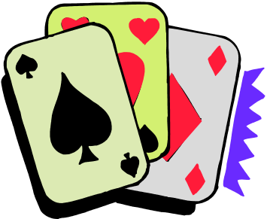
//refer cards to new ArrayList
//set top to the top of the deck 51

//loop through all suits
//loop through all faces 1 to 13
//add a new TwentyOneCard to the deck

//make a dealCard() method that returns the top card

//write a shuffle() method
//use Colletions.shuffle
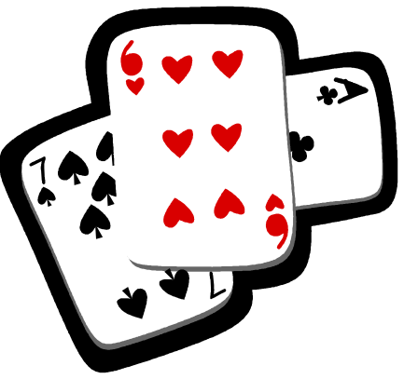
//reset the top card
Files Needed ::
Card.java
TwentyOneCard.java
Deck.java
DeckRunner.java
( CardRunner.java )
Sample Output
Print out 52 cards

Shuffle

Print out 52 cards

